**AI 620 Emerging Topics in Artificial Intelligence**

**HOS09A DeepAR Models**

03/28/2023 Developed by Yared Shewarade

09/23/2024 Updated by Anh Nguyen

11/19/2024 Reviewed by Jonathan Koerber

School of Technology and Computing (STC) @City University of Seattle (CityU)

**Before You Start**

* The directory path shown in screenshots may be different from yours.
* Some steps are not explained in the tutorial**.** If you are not sure what to do:
  1. Consult the resources listed below.
  2. If you cannot solve the problem after a few tries, ask the courses student worker for help.

**Learning Outcomes**

Students will be able to learn:

* Introduction to DeepAR Models
* Time series forecasting with DeepAR

**Resources**

* Tripuraneni, S., & Song, C. (2019). *Hands-on artificial intelligence on amazon web services: Decrease the time to market for AI and ML applications with the power of AWS* (1st ed.). Packt.

# Introduction to DeepAR Models

DeepAR, which is offered by Amazon SageMaker, is a deep learning algorithm based on the recurrent neural networks designed specifically for time series forecasting. It is a supervised learning algorithm for forecasting scalar (one dimensional) time series that could estimate the future probability distribution instead of a specific number. Time series forecasting use cases are certainly the most common time series use cases, as they can be found in all types of industries and in various contexts. Whether it is forecasting future sales to optimize inventory, predicting energy consumption to adapt production levels, or estimating the number of airline passengers to ensure high-quality services, time is a key variable.

DeepAR is a forecasting method based on autoregressive neural networks, and it learns about a global model from historical data of all-time series in the data set. DeepAR employs **Long Short-Term Memory (LSTM),** a type of**Recurrent Neural Network (RNN)**, to model time series. The main idea of RNNs is to capture sequential information.

# Time series forecasting with DeepAR

**Note:** Open Notebook using SageMaker. Follow the steps in HOS07 to open a Notebook.

* 1. **Install the required module and prepare the data.**

Let’s download the data and transfer to S3.

Note:- The dataset is provided with this file in GitHub or download from [here](https://archive.ics.uci.edu/ml/datasets/ElectricityLoadDiagrams20112014), upload to your notebook.

* 1. **Type the following in your notebook to train and test splits**

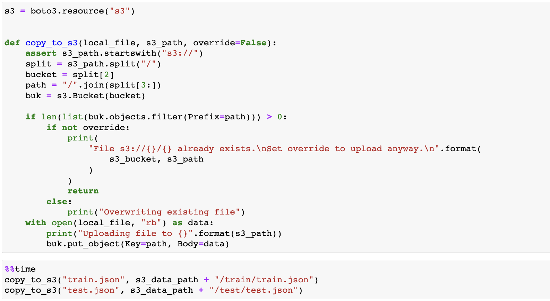



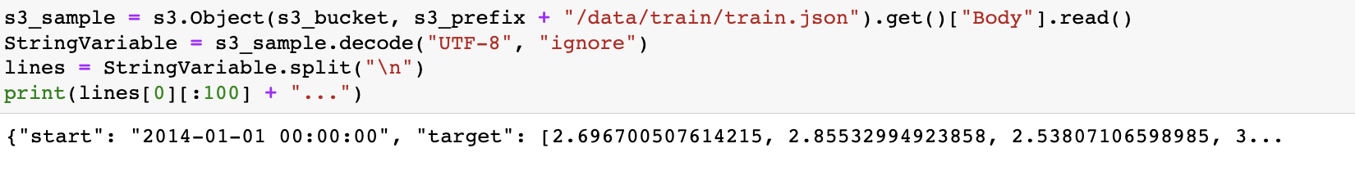

* 1. **Training the model**

Let’s train the DeepAR model once we have the data available in the correct format for training.

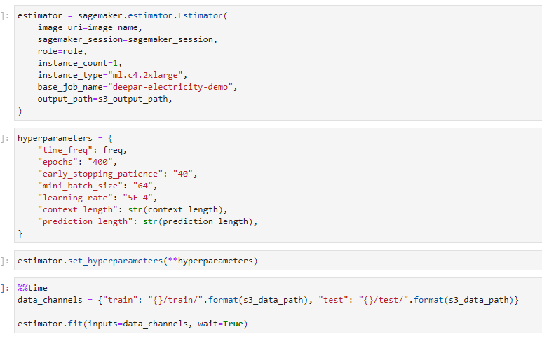

Wait for the model to finish training. After that, let’s plot the resulting time series for ten customers for the first two weeks of 2014.

The result is:

Take the screenshot for all steps and save it in your local repository along with your code.

**HOS submission instructions:**

1. Please install the GitHub Desktop: <https://cityuseattle.github.io/docs/git/github_desktop/>

2. Clone, organize, and submit your work through GitHub Desktop: <https://cityuseattle.github.io/docs/hoporhos>